***PAAREES PERFUMES***

***VERSACE***

***FOR UNISEX***

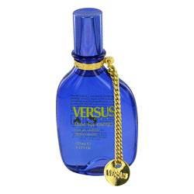

# 

# *Time For Energy*

## *Description:*

Time For Energy by Versace Perfume. Time For Energy is a fresh, crisp fragrance for women with a decidedly citrus scent. Released by Versace in 2002, the fragrance is energetic and lively, with delicious notes of mandarin orange, mint and lemon tree combined with feisty green tea and yuzu. The combination of these notes creates a scent that is invigorating and fun without being overpowering. This is a great fragrance for wearing to the gym or anywhere that you want to feel energized and ready to take on the world.